**Kentucky Fried Chicken**

**RULES:** Practical Shooting Handbook, Latest Edition **COURSE DESIGNER:** Ike Starnes

|  |  |
| --- | --- |
| **START POSITION: See written stage briefings.** | |
| **STAGE PROCEDURE**  Engage targets from within the shooting area. | **SCORING**  **SCORING:** Comstock 26 rounds.  **TARGETS:** 13 cardboard  **SCORED HITS:** 2 Best hits per carboard will be scored.  **START-STOP:**  Audible - Last shot  **PENALTIES:** Mike -10, NS -10, Procedural -10 |

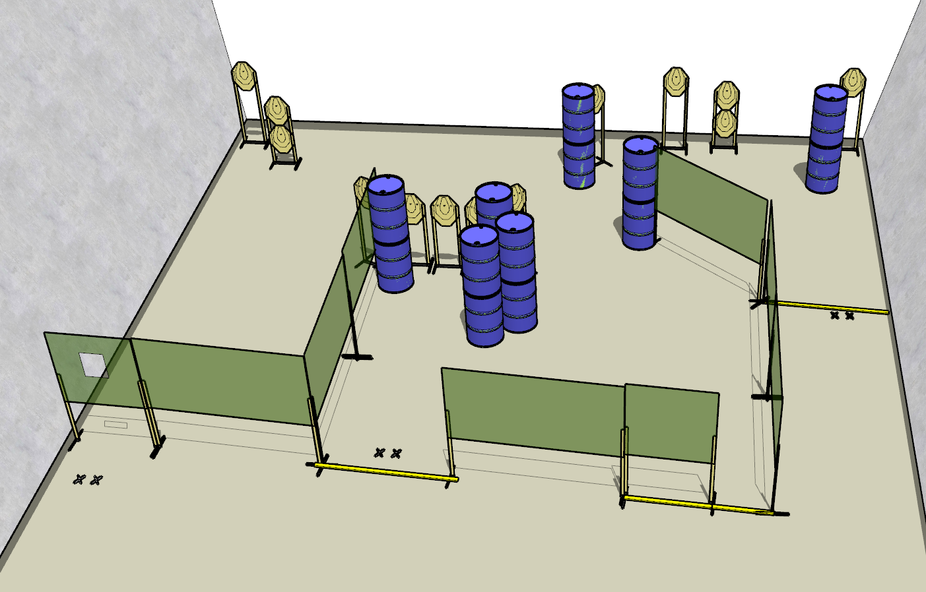

**Written Stage Briefings:**

**Stage 1 –** is a 26-round, 130 point, Comstock Long Course. There are 13 cardboard targets. The best 2 hits per cardboard target will be scored.

**Handgun start position** is both feet on left side Xs, wrists below belt. The handgun is **loaded** and holstered.

**PCC start position** is both feet on left side Xs. PCC is **loaded** with buttstock on belt with muzzle pointed at the center of the rear berm.

On the audible start signal, engage targets from within the shooting area.

**Stage 2 –** is a 26-round, 130 point, Comstock Long Course. There are 13 cardboard targets. The best 2 hits per cardboard target will be scored.

**Handgun start position** is both feet on center Xs, wrists below belt. The handgun is **unloaded** and holstered.

**PCC start position** is both feet on left side Xs. PCC is **unloaded** and held in both hands with buttstock on belt.

On the audible start signal, engage targets from within the shooting area.

**Stage 3 –** is a 26-round, 130 point, Comstock Long Course. There are 13 cardboard targets. The best 2 hits per cardboard target will be scored.

**Handgun start position** is both feet on downrange Xs, wrists above shoulders. The handgun is **loaded** and holstered.

**PCC start position** is both feet on downrange Xs, strong hand wrist above shoulders. PCC is **loaded** with buttstock on belt.

On the audible start signal, engage targets from within the shooting area.